Behavioral Medicine & Sleep Disorders Research Summer Institute (BSM)

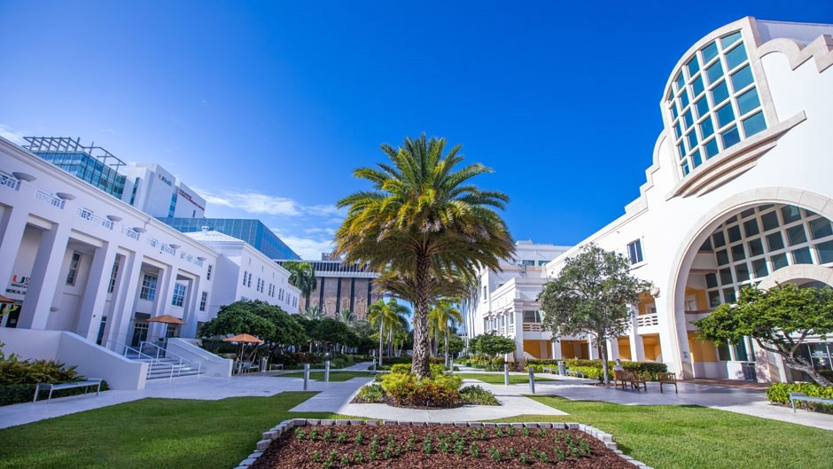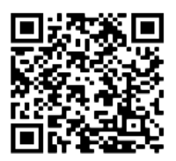

*All Expense-Paid Summer Institute for Junior Faculty*

## Where:

The BSM Summer Institute will convene in the Department of Psychiatry and Neurology at the University of Miami, 1120 NW 14th Street, Miami, FL 33136

**July 14 – July 25, 2025**

## How:

The Summer Institute brings together participants to the Miller School of Medicine, University of Miami, for a two-week didactic Summer Institute in June 2025, followed by a one

-week NIH Mock Study session in June 2026. A short mid-year meeting will be held during the BSM Institute’s academic year.

## Eligibility:

The institute provides funding to support travel and accommodations for up to 12 mentees. To be eligible to participate, you must be:

* PhD, Ed.D., or MD or equivalent doctoral degree
* Being a junior faculty with an academic appointment before participation
* US Citizen or Lawful Permanent Resident

# Overview

The Summer Institute on Behavioral Medicine and Sleep Disorders Research is a research- career-advancing opportunity at the University of Miami that is funded by the National Heart, Lung, and Blood Institute (NHLBI).

The BSM Summer Institute will provide junior faculty with intensive didactic and mentored research training in behavioral medicine and sleep disorders research.

This multidisciplinary training and mentoring institute aims to provide mentored learning opportunities to faculty in a top-tier academic environment, employing state-of-the-art methods and innovative techniques in their fields.

The Summer Institute focuses on six core competencies: conceptual knowledge in translational sciences, communication skills, research skill development, professionalism, leadership and management skills, and responsible research conduct.

# The Summer Institute will:

* Provide fundamental training by interdisciplinary faculty in behavioral medicine and sleep disorders research.
* Establish partnerships between mentors (Primary and Peer) and mentees based on their mutual research interests in the areas of translational behavioral medicine and sleep disorders research.
* Help mentees develop skills needed to develop innovative research ideas and apply for research funding to support their independent academic careers.
* Conduct grant-writing workshops to promote sustainable independent research careers.
* Leverage existing remote learning platforms to provide continuing support, mentorship, and coaching while developing manuscripts and research proposals.

# Program Director

# Girardin Jean-Louis, PhD

# Professor of Psychiatry and Neurology, University of Miami

## Learn More/Apply:

For more information, please visit the application website at:

tinyurl.com/2p8u3daa

**You may also visit our website at: https://med.miami.edu/tscs**

***Pre-Application:***

# BSM Co-Directors

### Indu Ayappa, PhD

*Icahn School of Medicine*

### Tatjana Rundek, MD

*Miller School of Medicine*

# Contact Information

### Debbie Chung, PhD

*Executive Director*

[*bxc1729@.miami.edu*](mailto:bxc1729@.miami.edu)

**Freddy Zizi, MBA**

*Research Training Initiatives* [*fxz182@.miami.edu*](mailto:fxz182@.miami.edu)